Cold-water Treading

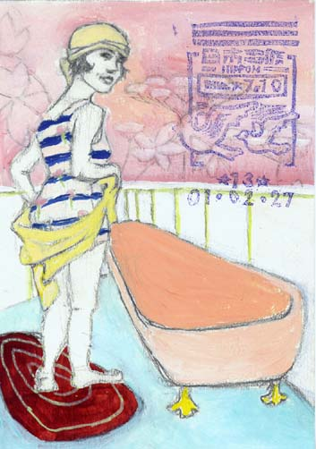
- Be used in place of dew-walking when the weather turns cold and snowy or, if you do not have a safe lawn to walk on.
- Make certain your feet are warm before you begin.
- Place a large tub in the bathtub or shower
  - Fill the tub (or a deep pan large enough to accommodate standing in, with your feet flat on the bottom without toes curled up to fit) with cold tap water to just above your ankles or just below your calves.* You may want to begin with lukewarm water, but as you become accustomed to the practice you can use colder water. In winter you can add some fresh snow to further cool the water.
- Holding on to a fixed bar or grip for stability, begin marching in the water. March in place for a few seconds up to no more than 4 minutes. Keep your feet in constant motion.
- Afterwards walk on a towel to dry your feet or use the towel to dry them vigorously.
- Cold-water treading increases circulation, and helps build resistance to infections.
  - It is also a good technique for leg cramping or leg pain that comes from exertion. It is also beneficial for someone who stands a great deal during the day or who suffers from cold feet at night.

*After you have become accustomed to water-treading in ankle-deep water, you can move up to knee-deep water for added benefit; but water-tread in this deep cold water for no more than 1 minute.

